Imaging

Step 1 –To create image of the pendrive click on Create Disk Image.

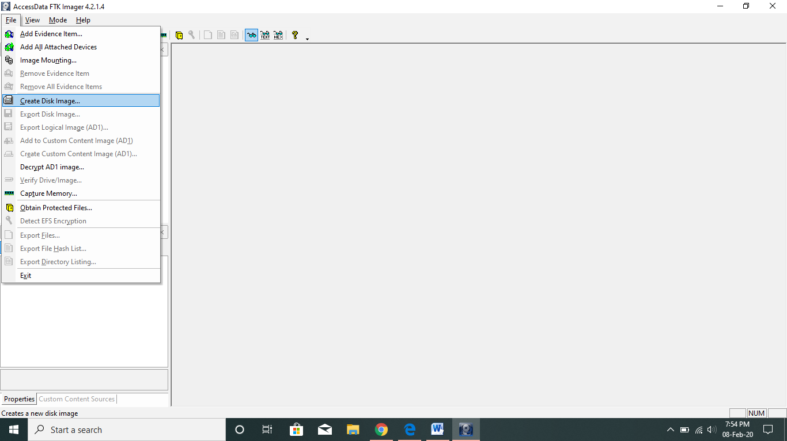

Step 2 –Select the evidence type and click on Next button.

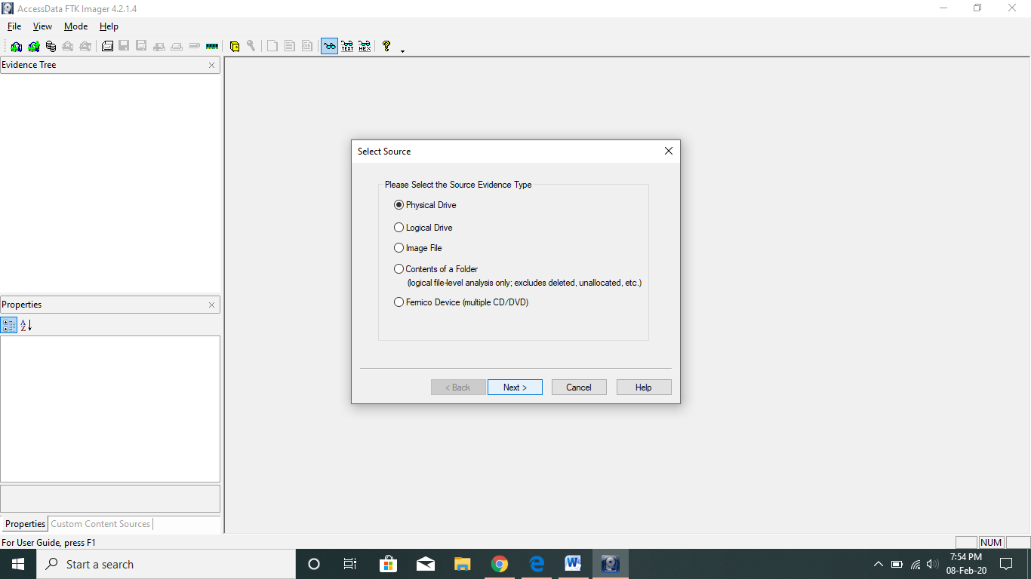

Step 3-Now select the source drive and click on finish button.

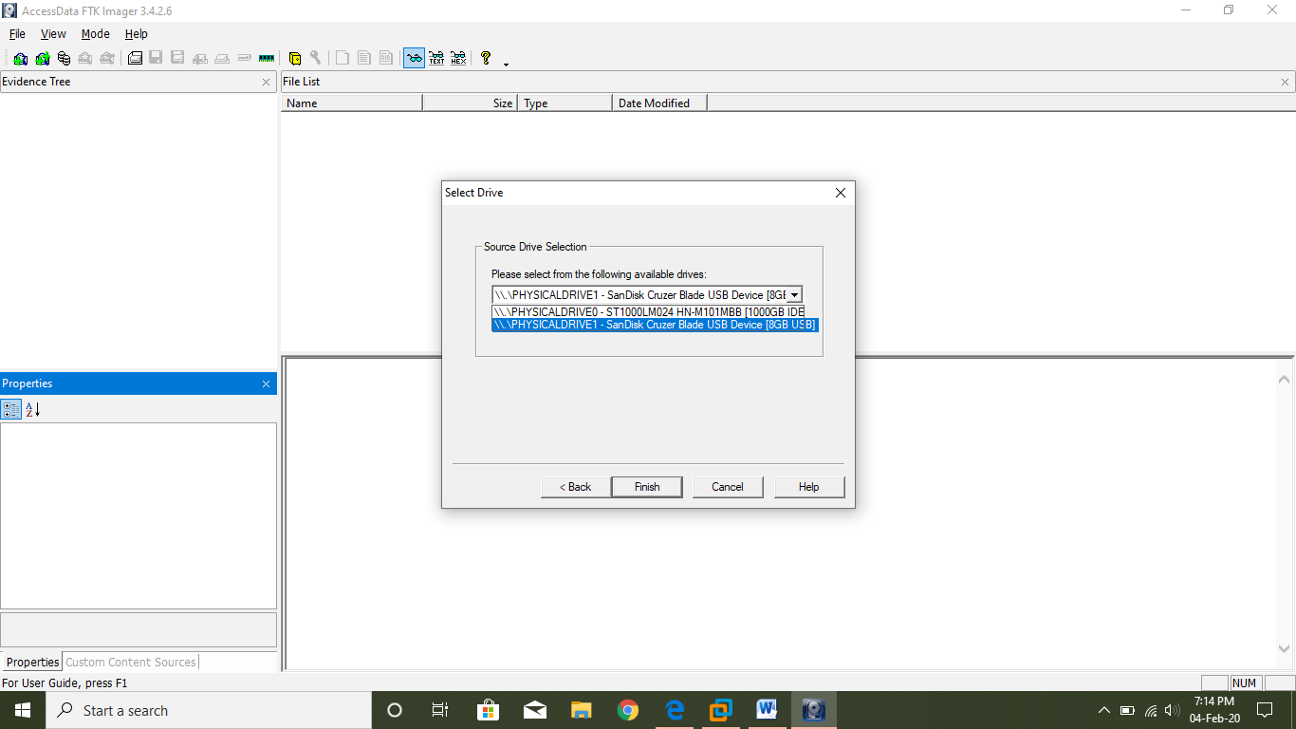

Step 4 -Click on "Add" button to add the destination location to save the image.

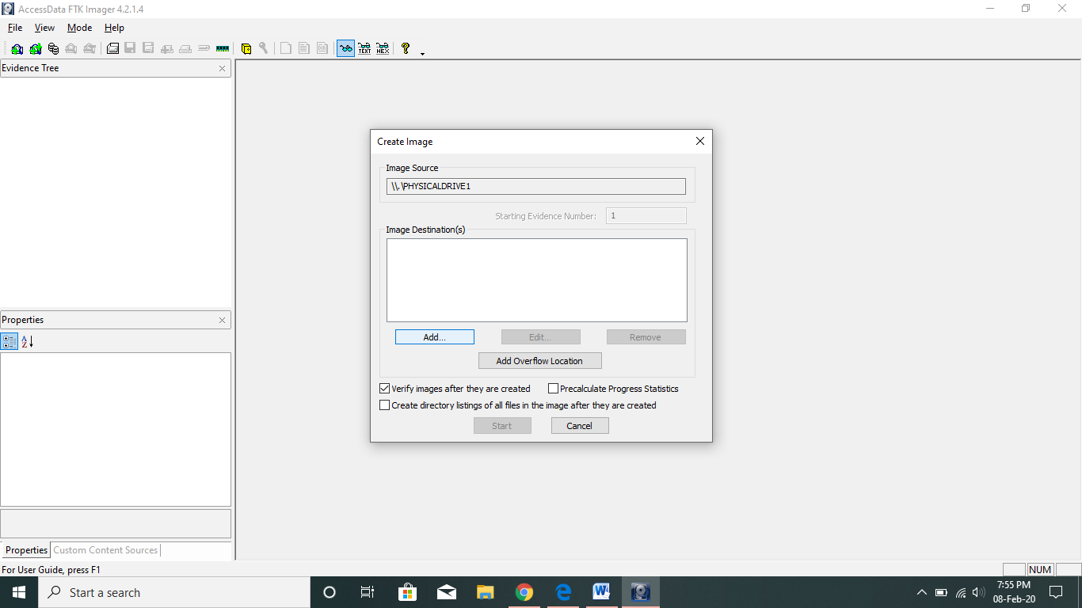

Step 5 –Select the image type.

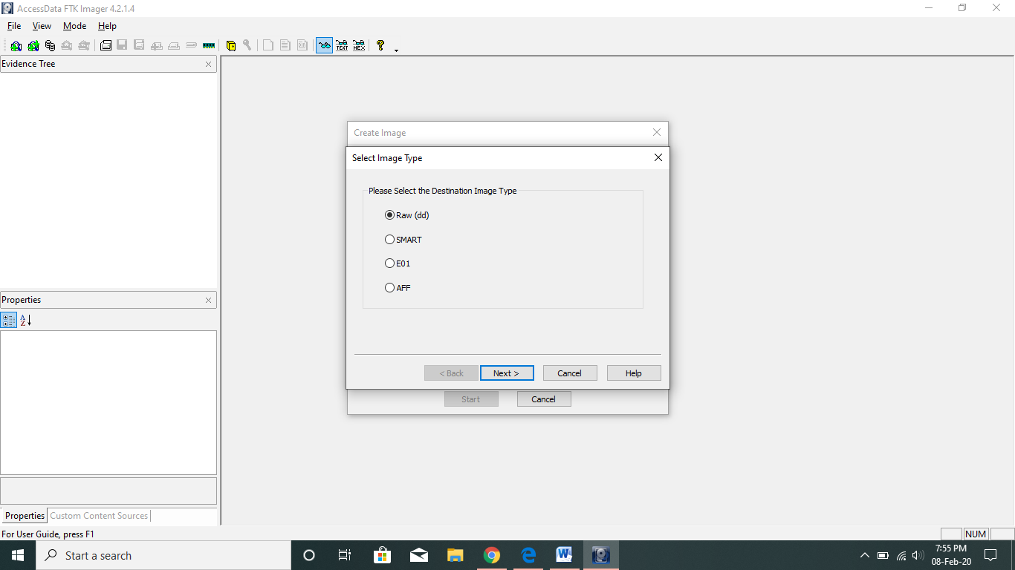

Step 6 –Add information about the evidence and select the image destination and click on Finish button.

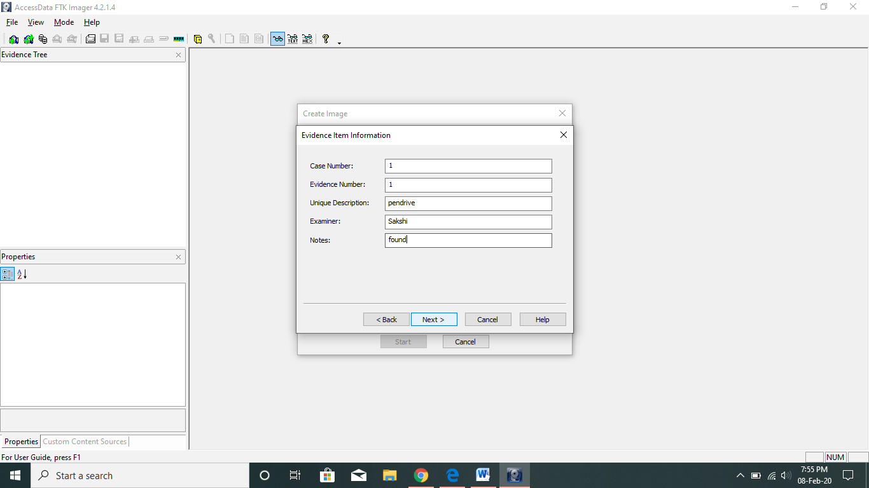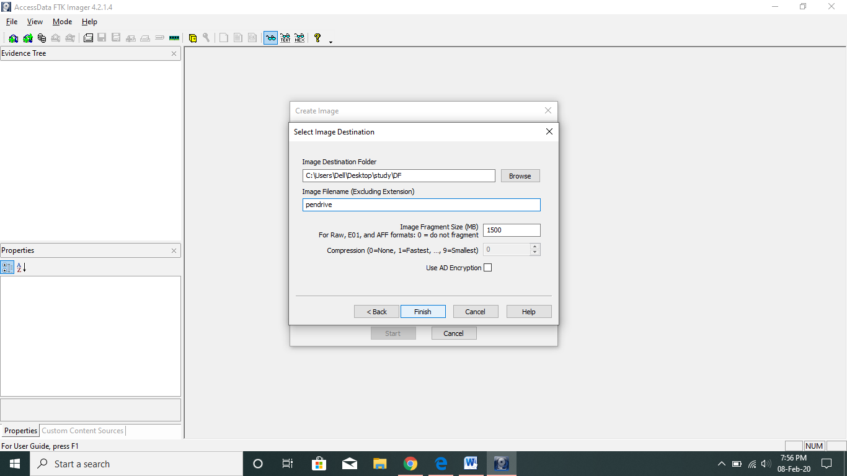

Step 7-Select the Start button to start creating the image of pendrive.

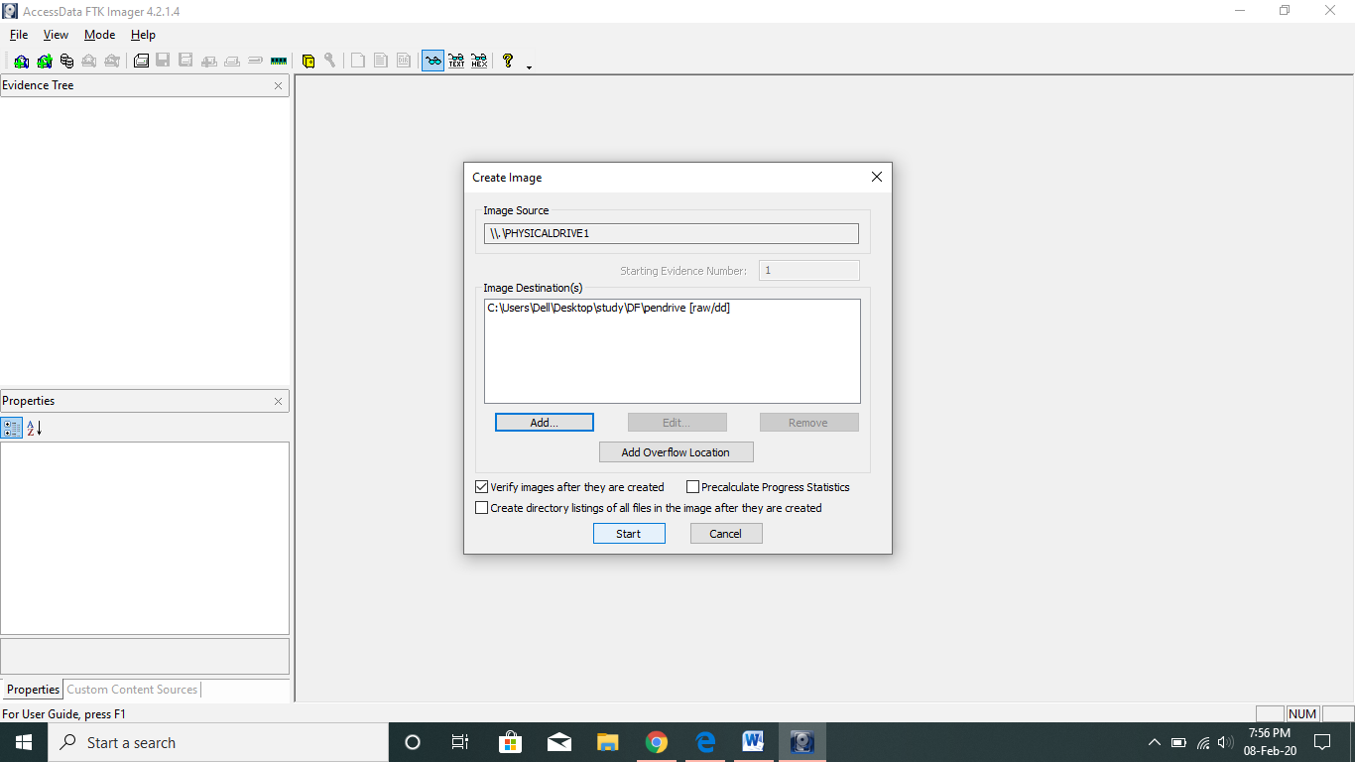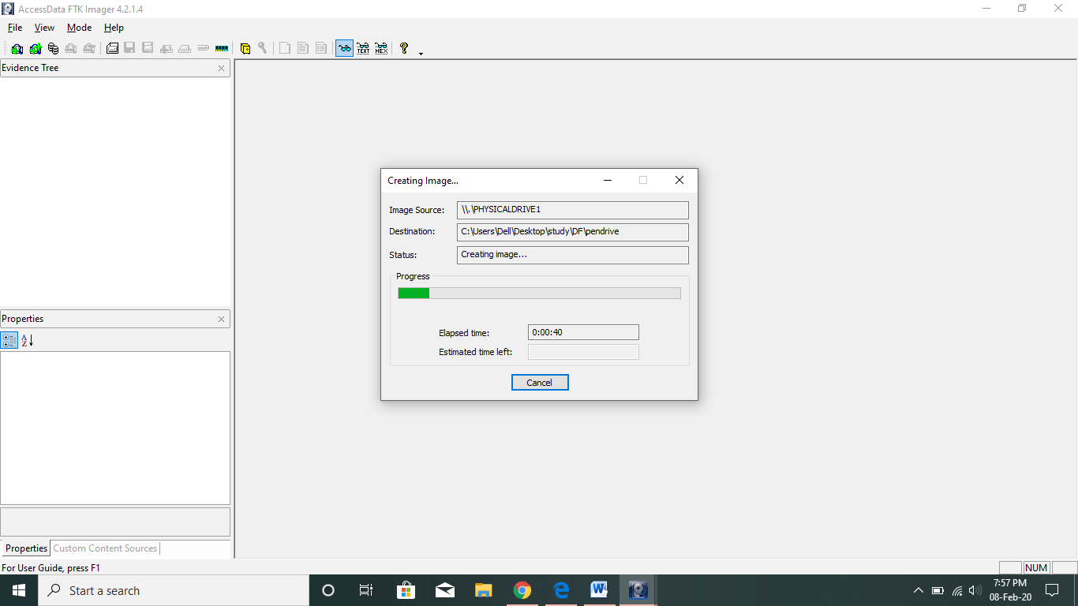

Now the image will be created at the added destination. After completion of imaging, the hash value of the image will be calculated using MD5 and SHA1 algorithm and will be displayed as shown below. And If we require a details report of the Pendrive like Pendrive Model, Serial Number, Number of Sectors, Cylinders etc.. we have to click on "Image Summary".

